

92nd CONVENTION
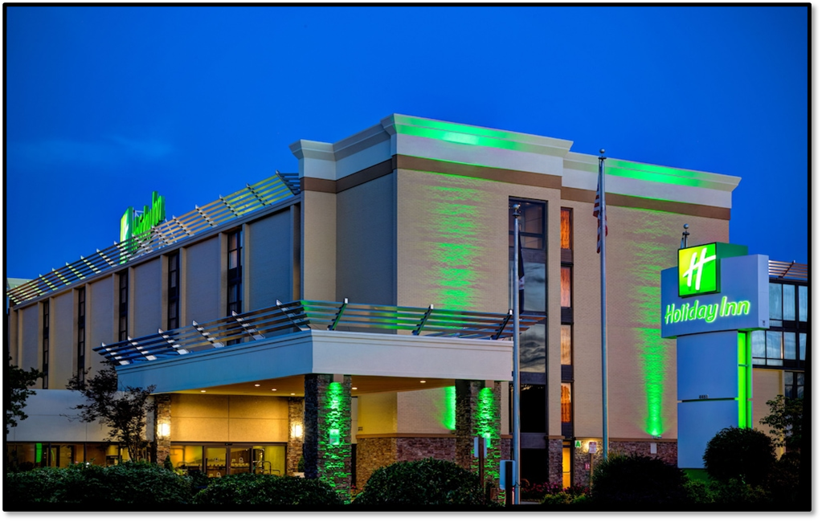
92nd Convention Joint Opening Minutes

2024 92nd Annual Convention
Joint Opening Session 6/7/2024

Commander King: I now call to order the 92nd Annual Convention of the Disabled American Veterans and Auxiliary, Department of Virginia.
Time is 0900______
Adjutant Gregory will now read the call to convention.

Adjutant Gregory: The Constitution and Bylaws of the Disabled American Veterans, Department of Virginia, state that the supreme legislative powers of this organization shall be vested in an Annual State Convention composed of the Department Officers, the Past Department Commanders, and representatives of the chapters.

In accordance with these directives, I, Lisa Gregory, Department Adjutant declare the 92nd Annual Convention of the Disabled American Veterans, Department of Virginia, to be convened in Roanoke, Virginia, at 9:00 a.m., June 7th, 2024.
Consideration and disposition of business brought before this convention shall be in accordance with the National Constitution and Bylaws and the Constitution and Bylaws of the Department of Virginia, now in force.

Commander King: Chaplain Coker-Bell will you lead us in the opening prayer.

Chaplain Coker-Bell: Dear God,
As we gather together, we ask for your spirit of unity to be present among us. Help us to put aside any personal agendas or differences and work together in harmony towards our common goal. Let this be our desire as we engage in discussions and make decisions that impact others.
We, the DAV trust that with your guidance and grace, we can achieve a sense of unity and work together effectively. May our words be filled with love and respect for one another, and may our actions reflect the unity we strive for.
Your love is what we seek as we continue to encourage and support veterans and their families.
Glory to God during this time we will share together. Amen.

Commander King: Faith Fellowship Honor Guard, Post the colors

Sr. Vice Smith: Oath of Allegiance to the Flag

Commander King: Adjutant Gregory will read the DAV Mission:

Adjutant Gregory: We are dedicated to a single purpose: empowering veterans to lead high-quality lives with respect and dignity. We accomplish this by ensuring that veterans and their families can access the full range of benefits available to them; fighting for the interests of America's injured heroes on Capitol Hill; and educating the public about the great sacrifices and needs of veterans transitioning back to civilian life.

- Providing free, professional assistance to veterans and their families in obtaining benefits and services earned through military service and provided by the Department of Veterans Affairs (VA) and other agencies of government;
- Providing outreach concerning its program services to the American people generally, and to disabled veterans and their families specifically;
- Representing the interests of disabled veterans, their families, their widowed spouses and their orphans before Congress, the White House and the Judicial Branch, as well as state and local government;
- Extending DAV’s mission of hope into the communities where these veterans and their families live through a network of state-level Departments and local Chapters; and
- Providing a structure through which disabled veterans can express their compassion for their fellow veterans through a variety of volunteer programs.

Commander King: Introduction of Officers

Senior Vice Commander James Smith, Jr.

1st Junior Vice Commander Rich Lehmann

2nd Junior Vice Commander Dwayne Ramey

Judge Advocate Stephen Combs

Chaplain Patricia Coker -- Bell

Immd. Past Commander PDC Francis Mitchell

Adjutant PDC Lisa Gregory

Treasurer PDC Robert (Bob) Cox

Department Inspector Ana Alicea-Diaz

Officer of the Day Terry Early

Sergeant-at-Arms Mike Giles

RECOGNITION OF:

Past Department Commanders

National Service Officers

Department Service Officers

Chapter Service Officers

Hospital Service Coordinators

CDCE Volunteers

The Department of Virginia has quite a few members serving on important National Line and Interim Committees positions

PDC Cynthia Madison is the National 3rd Junior Vice Commander
PDC Jim Procunier (NC) is the National 4th Junior Vice Commander

Serving on National Interim Committees:

PNC/PDC Rob Reynolds, Constitution and Bylaws

PDC Lisa Gregory, Employment Committee

PDC Denice Williams, The Charitable Service Trust Board of Directors

In the Commanders and Adjutants Association, PDC Rita Aberegg, and PDC Lisa Gregory.

RECOGNITION OF GUESTS:

Our National Guest Mr. Dan Clare, Chief Communications and Outreach Officer

Mr. James Sanders, Director of Quantico & Alexandria National Cemetery

Ms. Rebecca Stackhouse, Director, VA Salem Health Care Center

Mr. Bill Barksdale, Assistant Director, Roanoke VA Regional Office

Show Video from National Commander Nancy Espinoza and National Adjutant Barry Jesinoski wishing the department a successful convention.

DAVA Commander Susan Schofield will now introduce the DAVA Officers and National Guest.

Senior Vice Commander: Pat McNabb

1st Junior Vice Commander: Tonyia Courtemanche

2nd Junior Vice Commander: Jennifer Chester

Adjutant: Linda Clevenger

Treasurer: Sandy Everton

Judge Advocate: Amy Bowser

Chaplain: Darlene Massey

Past State Commanders

CDCE Volunteers

DAVA National Guest: Diane Franz, Past National DAVA Commander

Commander King: Introduction of National Guest Dan Clare, Chief Communications and Outreach Officer. (Read Bio)
(Remarks by Dan Clare)

Introduction of Ms. Rebecca Stackhouse, Director VA Salem Health Care Center (Read Bio)
(Remarks by Ms. Stackhouse)

Introduction of Mr. Bill Barksdale, Assistant Director, Roanoke VA Regional Office (Read Bio)
(Remarks by Mr. Barksdale)

Introduction of Mr. James Sanders, (Read Bio)
(Remarks by Mr. Sanders)

Turn Podium to DAVA Commander

DAVA Commander Schofield: Introduction of DAVA National Guest Diane Franz.
(Remarks by Ms. Franz)

Commander King: I make the following appointments to the following Convention Committees.

Tellers of Election:

1. PDC Bob Cox (60) 2. PDC Rita Aberegg (7) 3. TC Lasker (34)

Credentials Committee:

- PDC Cynthia Madison (27) 2. Regina Lawrence (50)

3. Maria Santy (7)

Resolutions Committee:

- PDC John Simmons (22) 2. Shay Odom (13) 3. Mack McCallon (58)

4. Shamala Capizzi (10), Dept. BPTL, Stephen Combs (7), JAG, Advisor

Entertain a motion to confirm these appointments

Motion Rita Aberegg (7)__Second__ Julie Hoyte (48)___________
Motion Passed

We will now present Department Awards. We have two Chapters that have received their 75 years of Service Plaques. Can we have someone from Chapter 6 come forward. (wait for photos) Now can we have someone from Chapter 19 come forward.

National has also recently recognized members who have achieved 15,000 hours of Volunteer service. If you have received a 15,000 hour pin please stand.

Will the Awards Committee Chair come forward to assist with the Department Convention Awards.

Adjutant Gregory are there any announcements.

Adjutant Gregory: Fall Conference will be held at the Four Points Sheraton Richmond Airport, October 16-19, 2024 in Richmond Virginia. Theme will be the Wild West.

We will have a coffee/donut break in the Foyer immediately following this meeting.

The Memorial Service will start promptly at 11:00 in this room so please be on time.

The Nominating Committee will meet in Dogwood 1 at 11:15. Please be sure to attend the afternoon sessions.

The Convention Business Session will start at 8:30 tomorrow morning. Please be prompt since we have the presentation of resolutions for consideration by this body.

Commander King: Chaplain Coker-Bell will you lead the closing prayer.

Chaplain Coker-Bell: Loving God, Thank you for this time that we have spent together. As we leave this place today, may we be committed to serving and supporting members of the DAV and their families. Lord, show us ways that we can bless others each day. Help us to see your blessings around us in the simple, small things that bring us joy each day. As we leave this place, please fill us with peace. Help us to go forth with joy that can only come from you. Amen.

Sr. Vice Smith: Salute to the Flag

Commander King: We will reconvene at 8:30 a.m. tomorrow. Please be sure to attend the afternoon seminars and training that will be provided.

