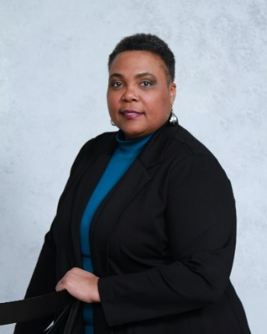

Marcia Stewart, a service-connected disabled veteran of the U.S. Navy, was elected Department 2nd Junior Vice Commander during the 92nd Department of Virginia Convention on June 8, 2024.

The Louisiana native joined the Navy in 1987 after graduating high school. Marcia’s naval career included active and reserve service in Virginia, California, Hawai’i, and Kuwait. During her naval career, Marcia worked as an Ocean System Technician Analyst (OTA), Sonar Technician (ST), Storekeeper (SK), Military Police (9545), and Customs Agent. Marcia retired in August of 2007 after 20 years of combined service.

Marcia’s civilian careers include teaching at the University of Maryland - Europe, Strayer University, Bryant & Stratton College, Averett University, and Advanced Technology Institute. Marcia also worked at General Dynamics and presently works at Newport News Shipbuilding (the nation’s sole designer, builder of nuclear-powered aircraft carriers and one of two designers and builders of nuclear-powered submarines for the U.S. Navy).

Marcia attended the American College of Education (ACE), where she earned a Doctor of Education in Leadership, and Hawai’i Pacific University where she earned a Master of Arts in Human Resources, and a Bachelor of Science in Business Administration Management. Marcia holds certifications in information technology, StrengthsFinder, and coaching.

Marcia is a member of Bernard L. Hines (Chapter 21) in Norfolk, VA, where she continues to support Veterans as a Chapter Service Officer (CSO). Before her election to the Department Line, Marcia served on the Department of Virginia Social Media, Membership, and Employment Committees, and at the Chapter level, she served in all line positions through Commander, and as member of the Audit and Women Veteran committees.