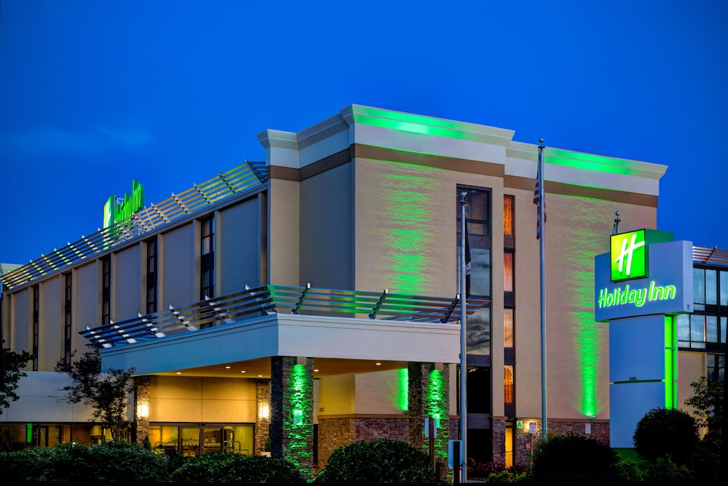

93rd Annual Convention

3rd DEC Meeting Minutes

**Spring Conference**

**3rd Department Executive Committee Meeting**

**March 15th, 2025**

**Commander Lehmann: Call to Order Time _11:04__**

**We will now have the invocation by the Chaplain.**

**Chaplain Floyd: O God, Creator of all things and the lover of our souls. Be our vision, our wisdom, and protect us as we go about the business of caring and meeting the needs of the DAV members and their families. Help us to focus on what truly matters. Search us, know us, try us, and reveal us. See if there be anything that is not pleasing in us and lead us in the way**

**everlasting. Make known to us the path of life, help us experience the full**

**joy of Your presence. We ask all this according to Your spirit and love. Amen.**

**Commander Lehmann: We will now have the Oath of Allegiance by SVC Ramey.**

**Sr. Vice Ramey: Oath of Allegiance to the Flag**

**Commander Lehmann: Adjutant Gregory will now read the MISSION STATEMENT**

**Adjutant Gregory:**

**We are dedicated to a single purpose: empowering veterans to lead high-quality lives with respect and dignity. We accomplish this by ensuring that veterans and their families can access the full range of benefits available to them; fighting for the interests of America's injured heroes on Capitol Hill; and educating the public about the great sacrifices and needs of veterans transitioning back to civilian life.**

**The entire mission statement is on the department and National webpage.**

**Rules of the Conference**

**I will only read the first six rules of the 31 (A copy of the 31 rules are on the Dept. Website).**

**Rule 1: Robert's Rules of Order, revised, will govern except as hereinafter specifically stated, and when not in conflict with the Disabled American Veterans Constitution and Bylaws and the Rules of the Convention.**

**Rule 2: For the purpose of recognition, a member of the Convention must (a) address the chair as Comrade Commander; (b) state name and chapter or title; (c) proceed only after recognition from the chair.**

**Rule 3: Debate on any question shall be limited to five minutes for each speaker except by consent of two-thirds of the delegates present.**

**Rule 4: Not more than two (2) representatives from any one Chapter shall be permitted to discuss any one subject except by a two-thirds (2/3) consent.**

**Rule 5: Recognition shall be granted only once to any one speaker on any one subject. A rebuttal of not more than two minutes may be permitted. Additional recognition may be granted by two-thirds (2/3) consent.**

**Rule 6: No person who has spoken for or against any motion, resolution or report on the Convention floor shall be permitted to make a motion to table. A motion to table is not debatable and shall require a majority affirmation vote. A tabled motion may be taken from the table for reconsideration by a majority vote.**

**I will now do the Roll Call.**

***DEPARTMENT ELECTED OFFICERS*: *Initials***

**Commander RICH LEHMANN (50) /___x______/**

**Sr. Vice Commander DWAYNE RAMEY (26) /____x_____/**

**1st Jr. Vice Commander KIMBERLY BARKLEY (27) /____x_____/**

**2nd Jr. Vice Commander MARCIA STEWART (21) /____x_____/**

**Judge Advocate STEPHEN COMBS (7) /___exc______/**

**Chaplain PATRICIA COKER-BELL (22) /___exc______/**

**Immed. Past Commander KING (26) /____exc_____/**

***DEPARTMENT APPOINTED OFFICERS: Initials***

**Adjutant GREGORY (7) /____x_____/**

**Treasurer COX (60) /_____x____/**

**Inspector ALICEA-DIAZ (13) /_____x____/**

**Officer of the Day BAILEY (20) /_____x____/**

**Sergeant at Arms WATKINS (28) /_____exc____/**

***Past Department Commanders: Initials***

**Francis MITCHELL (6) /­­­­­­­_________/**

**Cynthia BAILEY (20) /____x_____/**

**John SIMMONS (22) /____x_____/**

**Lisa GREGORY (7) /____x_____/**

**Denice WILLIAMS (22) /____x_____/**

**Jim PROCUNIER (10) /_________/**

**Cynthia MADISON (27) /____x_____/**

**Rita E. ABEREGG (7) /____x____/**

**David CUFF (60) /_________/**

**Dan MILLER (58) /_________/**

**Stephen D. PERKINS (23) /_____x____/**

**Robert D. COX (60) /_____x____/**

***Chapter DEC Initials***

**2 SHARON DORSEY MONROE /___x___/**

**EDWIN MARTINEZ /________/**

**3 DAVID RABORN (SUSPENSION) /_________/**

**LISA OLIPHANT /_________/**

**5 MURPHY COLEMAN /___x_____/**

**OTIS DOWTIN /_________/**

**6 ISADORE MAJOR /____x_____/**

**ROBERT MCDOWELL /_________/**

**7 MARIA SANTY /____x_____/**

**JEFF OGILVIE /_________/**

**9 WARREN G. THOMPSON /_________/**

**CHRISTIAN NELSON /_________/**

**10 ANNA LUTZ /_________/**

**SHAMALA CAPIZZI /_____x____/**

**13 LARRY BREWER /____x_____/**

**ANA ALICEA-DIAZ /_________/**

**15 JOEL D. COURTEMANCHE /_____x____/**

**MIGUEL ACEVEDO /_________/**

**17 WILLIAM B. HILL /____x_____/**

**LESTER JOHNSON /_________/**

***Chapter DEC Initials***

**19 JANET L. ROBERSON /_________/**

**MAYNARD DODD /_________/**

**20 DANNY MILLER /____x_____/**

**WILLIE SHOWELL /_________/**

**21 EDNA MYERS /_____x____/**

**DONNELL CEPHUS /_________/**

**22 MICHELE HINTON /____x_____/**

**LARRY A. ROMAINE /_________/**

**23 STEPHEN D. PERKINS /_____x____/**

**ROGER L. WILSON /_________/**

**24 BRUCE OREBAUGH /_________/**

**DAVID BAXLEY /_________/**

**26 DORIS WHITE /_____x____/**

**DOTTIE MOORE /_________/**

**27 DENNIS CONLEY /____x_____/**

**CEDRIC BARKLEY /_________/**

**28 MICHAEL L. BAGLEY /____x_____/**

**JOHN W. BONNER /_________/**

**30 GLENN BROWN /___x______/**

**WAYNE SANDRIDGE /_________/**

**31 CRAIG SMITH /_________/**

**MONTIE DALE ALBERT /_________/**

**33 TYRELLE FELDER /_____x____/**

**WILLIAM SEARFASS /_________/**

***Chapter DEC Initials***

**34 LARRY GRIFFIN /_____x____/**

**ETHEL SMITH /_________/**

**35 RONNIE L. ROBBINS /_________/**

**JACKIE D. BRANHAM /_________/**

**40 NONE /_________/**

**NONE /_________/**

**48 JULIE HOYTE /_____x____/**

**LOREN SMITHWEST /________/**

**50 OTIS ROYSTER /____x_____/**

**JACK BOLAN /_________/**

**52 ROBERT HAYZLETT /_________/**

**MARC THOMAS /_________/**

**56 DOUG COLLINS /_________/**

**NONE /_________/**

**57 LLOYD WILSON /_________/**

**LUTHER (TOM) WARD /_________/**

**58 MACK MCCALLON /____x_____/**

**LOUIS VALCOURT /_________/**

**60 CHRISTOPHER CHENEY /_____x____/**

**RONNIE PERDUE /_________/**

**61 THOMAS RILEY /_____x____/**

**NONE /_________/**

**Adjutant Gregory: Comrade Commander, we have a quorum. I will now read**

**communications to the Department.**

**Our National Representative for the Annual Convention will be Ed Hartman, National Inspector General.**

**The Testimonial Dinner for National Commander Dan Contreras will be April 12th at the Hills Hotel in Laguna Hills, CA. Room reservations can be made by calling 949-586-5000 and ask for the DAV rate. For more information contact Marine Kirkland at mkirkland@davcal.org.**

**We will be doing donations as we did at the Fall Conference. At 1:00 p.m. bring your donation/pledge forms to the registration area. Take your donation to the appropriate station. You need to complete a donation sheet for each donation.**

**I will announce the donations during the afternoon meeting.**

**Commander Lehmann: At this time I make the following appointments:**

**Tellers of Election: Sharon Dorsey Monroe, Chapter 2 Mitch Kuptz, Chapter 50**

**T.C. Lasker, Chapter 34**

**Is there a motion to accept the appointments.**

**Motion PDC John Simmons, 22, 2nd by Tyrelle Felder, 33_______**

**Motion Passed**

**At this time I appoint Chris Cheney as Acting JAG. Do I have a motion to accept this appointment**

**Motion _PDC Rita Aberegg, 7 2nd PDC Cynthia Bailey, 20___**

**Motion Passed**

**Commander Lehmann: Adjutant will you read the minutes of the 2nd DEC.**

**Adjutant Gregory: I am now prepared to read the minutes of the Department 2nd DEC Fall Conference 2024. The minutes were posted on the Department Website for review prior to this conference.**

**Motion to accept the Minutes as Posted by:**

**Motion Chris Cheney, 60 2nd by Julie Hoyte, 48_**

**Motion Passed**

**Commander Lehmann: The following reports were provided to the conference prior to convening:**

**Commander**

**Senior Vice Commander**

**1ST Junior Vice Commander**

**2ND Junior Vice Commander**

**Judge Advocate**

**Chaplain**

**Immediate Past Commander**

**Adjutant/EO**

**Treasurer/Financial**

**State VAVS Chair**

**Department Inspector**

**Each Officer will have an opportunity to provide an addendum to their report:**

**Commander (Addendum) No**

**Senior Vice Commander (Addendum) No**

**1ST Junior Vice Commander (Addendum) No**

**2nd Junior Vice Commander (Addendum) Yes**

**Judge Advocate (Addendum) No**

**Chaplain (Addendum) No**

**Immediate Pat Commander (Addendum) No**

**Adjutant (Addendum) No**

**Treasurer/Financial (Addendum) No**

**VAVS Chair (Addendum) No**

**Inspector (Addendum) No**

**Commander Lehmann: I will entertain a motion to accept the Officer reports and addendums.**

**Motion _PDC Cynthia Bailey, 20 2nd by PDC Rita Aberegg, 7_**

**Motion Passed**

**Commander Lehmann: The following reports were provided to the conference prior to convening:**

**Department Service Director**

**Awards Committee**

**Finance Committee**

**Audit Committee**

**Emergency Relief**

**Homeless Committee**

**Women’s Committee**

**Employment Committee**

**Membership Committee**

**Legislative/Benefits Protection Team Leader**

**Joint Leadership Council**

**Each Committee will have an opportunity to provide an addendum to their report:**

**Department Service Director (Addendum) No**

**Awards Committee (Addendum) No**

**Finance Committee (Addendum) No**

**Audit Committee (Addendum) No**

**Emergency Relief (Addendum) No**

**Homeless Committee (Addendum) No**

**Women Veteran’s Committee (Addendum) No**

**Employment Committee (Addendum) No**

**Membership Committee (Addendum) No Legislative Committee (Addendum) No**

**Joint Leadership Committee (Addendum) No**

**Commander Lehmann: I will entertain a motion to accept the Committee reports and addendums.**

**Motion PDC Cynthia Bailey, 20 PDC Denice Williams, 22___**

**Motion Passed**

**We will now have the Time and Place Report**

**Chair Zeola Brady: The Time and Place Committee report is as follows.**

**Registered Attendance (DAV) _____138____**

**Registered Attendance (DAVA) ______34____**

**Past Department Commanders ______8____**

**Chapters ______19___**

**Units ______16____**

**Banquet Attendance ______116___**

**Commander Lehmann: Is there a motion to accept the report?**

**Motion _Mack McCallon, 58 2nd by Tyrelle Felder, 33__**

**Motion Passed**

**Commander Lehmann: Any unfinished business?**

**Adjutant Gregory: None**

**Commander Lehmann: If your chapter/or anyone is going to donate to any of the service programs, please get the donation slip from Sgt-at-Arms Watkins or the registration table and return the donation to the registration desk by 1:00 and I will read the donations during the afternoon session.**

**PDC Luncheon will be in Woodlake I.**

**We will recess until 1:30.**

**DEC reconvenes**

**Commander Lehmann: The 2nd DEC is reconvened at 1:30.**

**Commander Lehmann: Do we have any New Business.**

**Adjutant Gregory: Yes.**

**In accordance with Article IV, Section 4-7, Para 3 Nominating Committee, Para 3.1 reads “Shall be elected by the DEC during the DEC Meeting of the Spring Conference. The committee will consist of five (5) members and two (2) alternates from different chapters.**

**Commander Lehmann: I now open the floor for nominations for the Nominating Committee:**

**Are there any nominations?**

**The following nominations were made:**

1. **_Valerie Gray, 21 nominates Gayle Sledge, 21**
2. **_Larry Griffin, 34 nominates Ethel Smith, 34**
3. **_PDC Bob Cox, 60 nominates PDC John Simmons, 22**
4. **_Dennis Conley, 27 nominates Julie Hoyte, 48_**
5. **Rick Davis, 26 nominates Doris White, 26__**
6. **_Otis Royster, 50 nominates Hallie Oxley, 50__**
7. **_PDC Rita Aberegg, 7 nominates PDC Bob Cox, 60**

**Are there any other nominations?**

**Are there any other nominations?**

**Are there any other nominations?**

**Hearing None, nominations are closed.**

**Commander Lehmann: I will now install the new Nominating Committee members and any DEC member or appointed positions who were not installed at the 1st DEC meeting. Please come forward to be installed.**

**Please Rise (Rap the Gavel Three Times)**

**Raise your right hands and repeat after me:**

**I, State your name Upon my word and honor, as a member of the Disabled American Veterans, in the presence of almighty God and my comrades, and before the flag of my country, accept the office to which I have been elected, I promise to perform the duties of such office, to the best of my ability. I promise to conduct myself in such a manner, at all times, and places as will only affect the good of the order, I promise to sustain and enforce the constitution and Bylaws of this organization. When my successor has been duly elected or appointed, and installed, I promise to surrender to him or her, all the property of this order, in my possession, all of which I now affirm.**

**You may lower your hands**

**Please return to your seats (Rap the Gavel 1 time)**

**Commander Lehmann: Adjutant Gregory will present proposals for the 2027 Spring Conference.**

**Adjutant Gregory: Conference Direct sent proposals to the following ten hotels. One responded back. The others either didn’t have space, our event was too far out or they could not meet what we were asking for. The following is the only one that accepted our bid.**

**Hotel Date Room $ F & B Min**

**Wyndham Garden Manassas 10 Mar 27- 14 Mar 27 $110 +tax**

**They did not list a F & B, but did have a meeting room rental listed instead so Conference Direct is working on that. They do equal out though in cost. They also offer free breakfast.**

**Hotel Madison & Shenandoah Valley Conference Center 10 Mar 27-14 Mar 27**

**F & B $10,000 and room rate at $110 plus tax.**

**The following other hotels were canvassed: Holiday Inn Charlottesville- Univ Area, Graduate by Hilton Charlottesville, DoubleTree by Hilton Hotel Charlottesville, Kimpton the Forum Hotel, Wintergreen Resort, Crowne Plaza Virginia Beach, Ceasars Virginia, Hilton Garden Inn Virginia Beach, Holiday Inn Express Charlottesville**

**Commander Lehmann: I WILL NOW ACCEPT A MOTION FOR THE SITE FOR THE 2027 SPRING CONFERENCE.**

**Motion PDC Cynthia Bailey, 20 makes a motion for the Hotel Madison, PDC Cynthia Madison, 27 2nd the motion**

**Motion Passed**

**Commander Lehmann: Assistant Adjutant Madison will now read the donations.**

**PDC Madison: Donations are as follows.**

**Donations Pledges**

**Emergency Relief Chapter 20, $500 Chapter 6, $150**

**Chapter 5, $500 Chapter 34, $150**

**Chapter 17, $50**

**Chapter 2, $100**

**Women Veterans Chapter 20, $500 Chapter 6, $150**

**Chapter 2, $100 Chapter 34, $100**

**Chapter 5, $500**

**Chapter 58, $500**

**Chapter 17, $50**

**Homeless Chapter 13, $500 Chapter 6, $150**

**Chapter 20, $500 Chapter 34, $100**

**Chapter 5, $500**

**Chapter 2, $100**

**Chapter 17, $50**

**DSC Chapter 20, $500**

**Chapter 5, $500**

**Chapter 2, $100**

**Chapter 58, $500**

**Social Media Chapter 20, $200 Chapter 34, $100**

**Wheelchair Games Chapter 20, $500 Chapter 34, $100**

**Golden Age Games Chapter 20, $200 Chapter 34, $100**

**Incarcerated Veterans Chapter 20, $200 Chapter 34, $100**

**Employment Chapter 20, $200**

**Chapter 2, $100**

**Winter Sports Clinic Chapter 20, $500 Chapter 34, $100**

**Chapter 58, $500**

**Disaster Relief Chapter 20, $5000**

**Chapter 13, $500**

**Total donations were $14,000 and total pledges were $1,250.**

**Commander Lehmann: Are there any announcements?**

**Adjutant Gregory: Yes. Reception will be from 5:30-6:30. The doors will open for those using carts, wheelchairs, or other assistive devices at 6:25.**

**Our theme tonight is Welcome to the Luau.**

**The 93nd Convention will be June 5th through 8th at the Holiday Inn Tanglewood, Roanoke, 4468 Starkey Road, Roanoke VA. CSO/DSO training will be conducted on Wednesday, June 4th. Our National guest will be Ed Hartman, National Inspector General.**

**Commander Lehmann: Good of the order**

**2nd National JVC/PDC Madison announced that she will be running for National Higher Office and is requesting the support of the Department of Virginia.**

**PDC Madison can you please come forward to officially announce your intent to run for National Higher Office.**

**Commander Lehmann: Can we have a motion to send a letter of support from the DEC for PDC Madison for her intent to run for higher office.**

**Motion Julie Hoyte, 48 2nd by Earl Bailey, 20_________**

**Motion Passed**

**Commander Lehmann: This is now the opportunity for those interested to announce their intentions to seek a department office.**

**(The following announced their intent to run for office; Dwayne Ramey, 20 for Commander, James Smith, 22 for Commander, Kim Barkley, 27, Marcia Stewart, 21)**

**Commander Lehmann: Motion to adjourn.**

**Motion Mack McCallon, 58 2nd by PDC John Simmons, 22**

**Motion Passed**

**Chaplain, please lead us in closing prayer.**

**Chaplain Coker Bell:**

**God, we thank you for this time we have spent in your presence today. Help us remember that you have given us more than we could have ever asked for or even imagined on this day. Help us to continually turn our eyes to you when**

**decisions must be made for the good of DAV members and their families. We thank you for all you bless us with each day. In your name, we pray, Amen.**

**Commander Lehmann: Final salute to the flag TIME _2:28___**